Spectral coherence: USDCAD and EURGBP
Method 21 / daily log returns / Welch magnitude-squared coherence / Alpari D1 full available history

Study setup
Logical pair: USDCAD , EURGBP
Broker symbols: USDCAD_i , EURGBP_i
Snapshot: 2026-11-03_majors_alpari_D1
Timeframe: D1
Matched return window: 1999-01-06 to 2026-11-02 (UTC bar dates)
Matched return count n: 7185
Dropped unfinished last bar dated 2026-11-03 UTC after a tick-volume check against the prior complete day.
Welch: fs=1.0, nperseg=256, noverlap=128, window=hann, detrend=constant
Headline: gamma^2 nearest f=1/5; also 1/21 and 1/63
Complete matched rows (Excel): USDCAD-EURGBP_Spectral_D1.xlsx
Complete matched rows (HTML table): USDCAD-EURGBP_Spectral_D1_data.html

Method carried forward
Magnitude-squared spectral coherence gamma^2(f) measures shared linear power between matched daily log returns of close, ln(close_t / close_t-1), at each frequency f (cycles per day). Quotes are not inverted. Welch settings are frozen: fs=1, nperseg=256, noverlap=128, window=hann, detrend=constant. Headline is gamma^2 at the frequency bin nearest f=1/5 (five-day cycle from the formula sheet). Also reported: gamma^2 nearest f=1/21 and f=1/63, mean gamma^2 over the frequency grid, and phase of the cross-spectrum at the 1/5 bin. Coherence is unsigned (0 to 1); phase carries timing. Same-sample Pearson r is a side check only. This is not causation and not a trading signal.

Results (headline)
gamma^2 near 1/5: 0.038620
bin f (1/5): 0.199219
phase at 1/5 (rad): 0.598725
gamma^2 near 1/21: 0.045220
gamma^2 near 1/63: 0.014078
mean gamma^2: 0.032573
Pearson r: -0.014622

Target-frequency summary
period | target_f | f_bin | gamma2 | phase_rad
5 | 0.2 | 0.19921875 | 0.03861974 | 0.59872526
21 | 0.04761905 | 0.046875 | 0.04521989 | -0.88090296
63 | 0.01587302 | 0.015625 | 0.01407795 | -1.9032246

Conclusion
Headline gamma^2 near f=1/5 for USDCAD and EURGBP: 0.0386 (bin f=0.199219, phase=0.5987 rad). At ~1/21: 0.0452; at ~1/63: 0.0141. Mean gamma^2 = 0.0326. Pearson r = -0.0146. This is frequency-domain linkage, not a trading signal.

Charts
Daily closes

Daily log returns

Spectral coherence gamma^2(f)
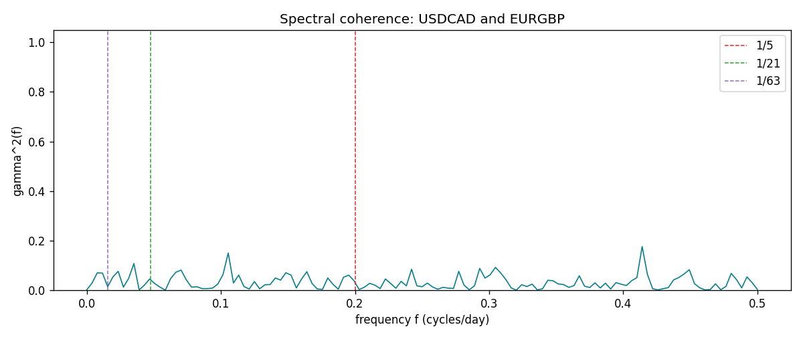

Data report
Matched rows and the coherence sheet are in the sibling Excel workbook named USDCAD-EURGBP_Spectral_D1.xlsx. Embedding all rows as a Word table is impractical; this file holds column summaries and the first and last 15 matched rows.
Columns: time, USDCAD_open, EURGBP_open, USDCAD_high, EURGBP_high, USDCAD_low, EURGBP_low, USDCAD_close, EURGBP_close, USDCAD_tick_volume, EURGBP_tick_volume, USDCAD_spread, EURGBP_spread, USDCAD_real_volume, EURGBP_real_volume, USDCAD_log_return, EURGBP_log_return
Column summaries (matched calculation rows)
column | count | mean | std | min | 25% | 50% | 75% | max
USDCAD_open | 7185 | 1.2666594 | 0.16886861 | 0.9168 | 1.1183 | 1.29841 | 1.37203 | 1.6183
EURGBP_open | 7185 | 0.78693389 | 0.09666561 | 0.5734 | 0.6876 | 0.83387 | 0.86521 | 0.9769
USDCAD_high | 7185 | 1.2715589 | 0.16882635 | 0.9336 | 1.1227 | 1.30381 | 1.3764 | 1.619
EURGBP_high | 7185 | 0.79000929 | 0.09704455 | 0.5789 | 0.6896 | 0.8369 | 0.8681 | 0.9799
USDCAD_low | 7185 | 1.2621046 | 0.16891061 | 0.9056 | 1.11396 | 1.29347 | 1.36776 | 1.6102
EURGBP_low | 7185 | 0.78423344 | 0.09648411 | 0.5682 | 0.6855 | 0.83166 | 0.86287 | 0.9661
USDCAD_close | 7185 | 1.2666836 | 0.16885076 | 0.916 | 1.118 | 1.29833 | 1.3723 | 1.6137
EURGBP_close | 7185 | 0.78697576 | 0.09666885 | 0.5735 | 0.6878 | 0.83391 | 0.86533 | 0.977
USDCAD_tick_volume | 7185 | 81049.359 | 147325.09 | 37 | 5563 | 40946 | 71633 | 1410818
EURGBP_tick_volume | 7185 | 87109.869 | 145486.28 | 154 | 6553 | 44326 | 81375 | 1424684
USDCAD_spread | 7185 | 23.430202 | 18.259258 | 0 | 9 | 17 | 40 | 60
EURGBP_spread | 7185 | 21.335421 | 19.123862 | 0 | 4 | 13 | 40 | 50
USDCAD_real_volume | 7185 | 1.8384377e+10 | 9.670755e+10 | 0 | 0 | 0 | 0 | 2.5751613e+12
EURGBP_real_volume | 7185 | 2.7864528e+10 | 1.3519652e+11 | 0 | 0 | 0 | 0 | 3.5726265e+12
USDCAD_log_return | 7185 | -8.08e-06 | 0.00514591 | -0.03859748 | -0.00283484 | 5.597e-05 | 0.00272835 | 0.03436319
EURGBP_log_return | 7185 | 1.874e-05 | 0.00486681 | -0.03067367 | -0.00262366 | -0.00010035 | 0.00255918 | 0.06075387
First 15 matched rows (selected columns)
time | USDCAD_log_return | EURGBP_log_return
1999-01-06 | -0.0003306769 | -0.013303338
1999-01-07 | 0.0015202092 | 0.011051402
1999-01-08 | -0.0020495197 | -0.004943862
1999-01-11 | -0.0035137769 | -0.0012752393
1999-01-12 | 0.0066194721 | 0.0033970309
1999-01-13 | 0.0045420214 | 0.00042381861
1999-01-14 | 0.0069376546 | -0.0019793588
1999-01-15 | -0.0056905671 | -0.0076715819
1999-01-18 | 0.00098344542 | 0.00071280921
1999-01-19 | 0.002748513 | -0.0014261269
1999-01-20 | -0.0059646885 | 0.0019960086
1999-01-21 | -0.0042823796 | -0.00071240297
1999-01-22 | 0.0025057712 | -0.0017118406
1999-01-25 | 0.00085579808 | -0.0054402425
1999-01-26 | 0.0001973879 | -0.00057438255
Last 15 matched rows (selected columns)
time | USDCAD_log_return | EURGBP_log_return
2026-10-13 | -0.0046395653 | 0.00020130374
2026-10-14 | 0.0015184751 | 0.0011241873
2026-10-15 | -0.0036101503 | -0.00087557391
2026-10-16 | -0.0034322068 | -0.0020380844
2026-10-19 | -0.0018835331 | -0.00056950988
2026-10-20 | -0.0037066008 | -0.0035906254
2026-10-21 | -0.00084691787 | -0.00140647
2026-10-22 | -0.0026307268 | -0.0018743924
2026-10-23 | 2.85545e-05 | 0.00082421033
2026-10-26 | 5.7106554e-05 | 0.00013133309
2026-10-27 | 0.0025379458 | -0.0019957343
2026-10-28 | -0.0038379274 | 0.00066967224
2026-10-29 | -0.00011436495 | -0.0011722209
2026-10-30 | -0.0010298736 | -0.0024205543
2026-11-02 | 0.00061519094 | 0.00089940465
First 15 frequency bins
f | gamma2 | phase_rad | period_days
0 | 0.0018366 | 0 | inf
0.00390625 | 0.02856556 | -1.0641307 | 256
0.0078125 | 0.07000268 | -2.3166643 | 128
0.01171875 | 0.06923998 | -1.7298456 | 85.333333
0.015625 | 0.01407795 | -1.9032246 | 64
0.01953125 | 0.0541003 | -1.5955646 | 51.2
0.0234375 | 0.07618915 | -1.7348547 | 42.666667
0.02734375 | 0.0127353 | -1.0287679 | 36.571429
0.03125 | 0.04787014 | -2.2072941 | 32
0.03515625 | 0.1077137 | -2.393166 | 28.444444
0.0390625 | 0.00148842 | -1.8851145 | 25.6
0.04296875 | 0.02066493 | 0.01100203 | 23.272727
0.046875 | 0.04521989 | -0.88090296 | 21.333333
0.05078125 | 0.0263975 | -1.5589804 | 19.692308
0.0546875 | 0.01239098 | 3.0138359 | 18.285714

